Image | 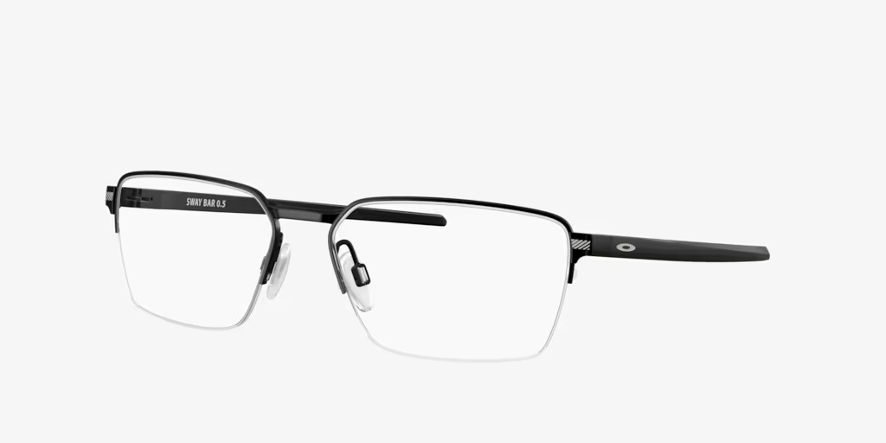
Brand | MICHEAL KORS
Model Name | OX5078 SWAY BAR
Price | RS 2499
PRODUCT DETAILS

